Tasks

1.Visit a nearby retail store or supermarket and take photos of at least three different in-store promotion techniques (such as product displays, standees, demo counters, or limited-time offer boards). For each, write a short description of what the promotion is and how it tries to attract customers.

2.Design a creative in-store promotion poster for a new soft drink launch, targeting college students. Your poster must include an eye-catching headline, a call-to-action, and a special offer (like 'Buy 1 Get 1 Free').<br><br><em><strong>Hint:</strong> Use Canva or any free online poster maker to create your design and export it as a PDF or image.</em>

3.Imagine you are the marketing manager for a popular sneaker brand. Write a step-by-step plan (5-7 steps) for running an in-store contest that encourages customers to try on and share photos of your new collection on Instagram, tagging the store for a chance to win a prize.

4.Analyze the in-store promotions used by any one of these brands: Zomato, Myntra, or Flipkart during their offline pop-up events or partner stores. List 3 elements that make their promotions effective and suggest one improvement for each.

Answer:-

1. In-store promotion techniques
Store visited: [D-Mart / Reliance Fresh / Local Supermarket]
Location: [Apne area ka naam likho]
No. | Promotion type | Description | Customer ko kaise attract karta hai
1 | Limited-time offer board | Entrance ke paas ek large red-yellow board laga tha: “Weekend Special – Buy 1 Get 1 Free” ya “Flat 30% OFF.” | Bright colours aur big discount percentage customer ko store mein enter karte hi offer notice karwate hain. “Weekend only” jaisi line urgency create karti hai.
2 | Product display / end-cap | Aisle ke end par biscuits, cold drinks, chips, cooking oil ya festive gift packs ka separate stacked display tha. | Aisle-end display har customer ko dikhai deta hai. Bulk stacking product ko popular aur value-for-money dikhati hai.
3 | Demo / sampling counter | Food section mein new juice, biscuit, noodles ya snack ka free tasting counter tha. | Free sample lene ke baad customer product ka taste check kar sakta hai. Agar product achha lage, toh purchase chance badh jata hai.
4 | Standees | Cosmetics, mobile recharge, new beverage ya bank-card offer ke standees store entrance aur billing area par lage the. | Vertical standee eye level par brand message aur offer ko quickly communicate karta hai.
5 | Checkout-counter display | Billing counter ke paas chocolates, chewing gum, small snacks, batteries aur mini personal-care products rakhe the. | Billing ke waqt customer low-price products impulse mein add kar leta hai.
Photo captions likhne ke liye:
- Photo 1: Limited-time discount board at [store name].
- Photo 2: Promotional product display/end-cap at [store name].
- Photo 3: Free sampling/demo counter at [store name].

2. Soft-drink promotion poster
Soft drink name: FizzUp
Target audience: College students

Poster content

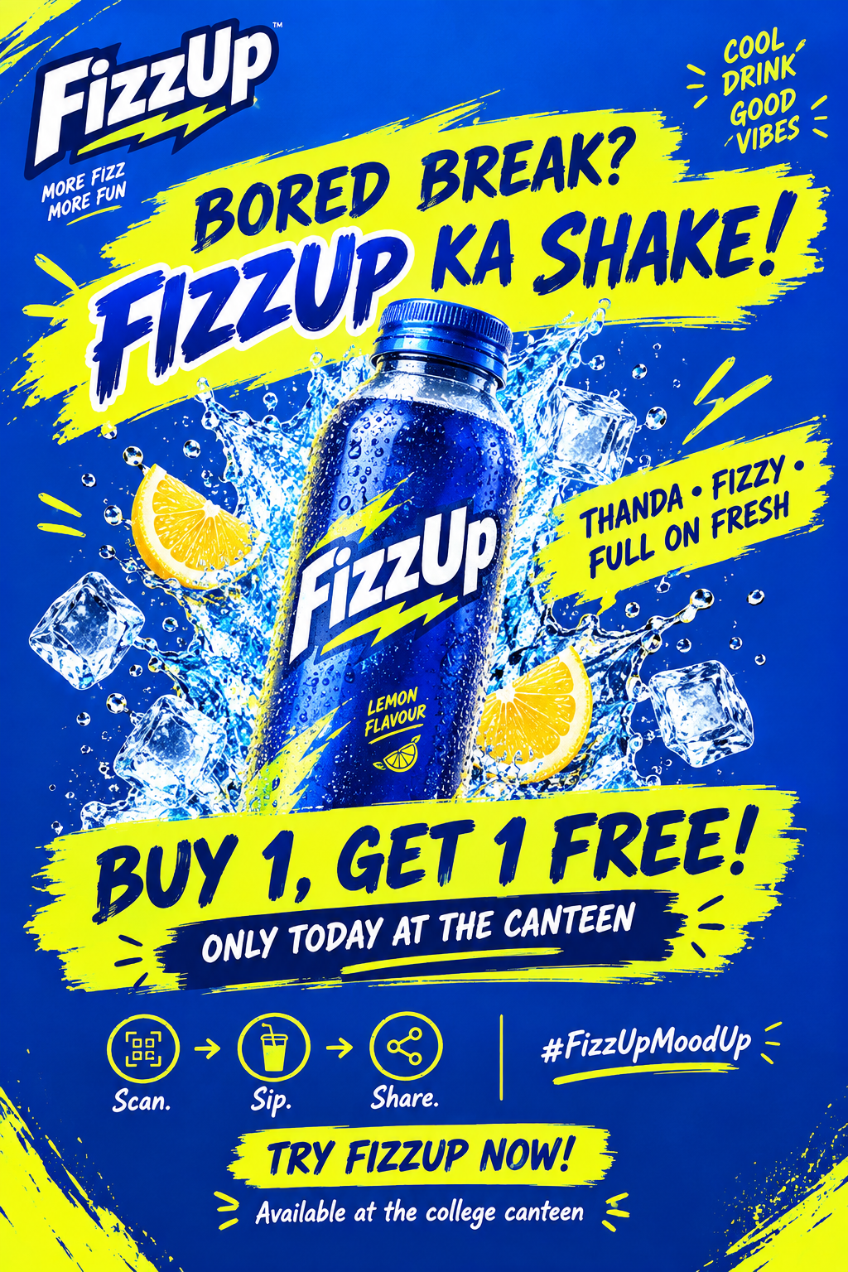

Design details
- Headline: “Bored Break? FizzUp Ka Shake!” bold, large aur playful font mein.
- Main visual: Centre mein chilled FizzUp can/bottle, ice cubes aur fizzy splash ke saath.
- Colour scheme: Blue background, neon yellow headline aur white offer text.
- Special offer: Yellow sticker/badge: “Buy 1, Get 1 Free!”
- Call-to-action: Bottom par large text—“Try FizzUp Now!”
- Extra engagement: QR code ke neeche “Scan & Win a Free FizzUp” add kiya ja sakta hai.
Poster ko canteen entrance, billing counter aur college noticeboard ke near lagana chahiye, kyunki yahan students food break ke time naturally rukte hain.

3. Sneaker in-store contest plan
Contest name: Step Into The Spotlight
Prize: New sneaker pair / ₹5,000 store voucher
- Store entrance par a large contest standee lagayenge: “Try. Click. Tag. Win!”
- New sneaker collection ko centre display par rakhenge, with sizes available aur clear “Try Me” signage.
- Ek attractive mirror/photo wall banayenge jahan neon lights aur brand hashtag—#StepIntoTheSpotlight—visible hoga.
- Customer ko naye sneakers try karne honge aur photo ya reel Instagram par post karni hogi.
- Post mein store ka official Instagram account tag karna aur campaign hashtag use karna mandatory hoga.
- Customer ko checkout desk par post dikhakar entry number ya digital confirmation lena hoga.
- Har week ek winner choose hoga based on creativity, style aur engagement; winner ko sneaker pair ya store voucher milega.

Why this contest works
- Customers product ko try karenge, isliye purchase confidence badhega.
- Instagram posts se store ko user-generated promotion milega.
- Friends/followers bhi new sneaker collection aur store discover kar sakte hain.
- Contest + prize ka combination customers ko store visit aur share karne ka reason deta hai.

4. Brand promotion analysis
Brand selected: Flipkart
Offline format: Flipkart Experience Zones / assisted-buying and pickup centres
Flipkart ne offline experience zones/pickup centres ka model use kiya hai jahan customers online order collect kar sakte hain, product demos dekh sakte hain, open-box delivery aur instant returns/exchanges ka option use kar sakte hain. Kuch centres trial rooms aur assisted buying bhi provide karte hain.theweek
Effective promotion element | Why it works | Suggested improvement
Product demo and assisted buying | Customer product ko samajh sakta hai aur staff se guidance le sakta hai. Online shopping ka doubt—especially electronics, fashion ya appliances ke case mein—reduce hota hai. theweek | Demo zone mein weekends par live demo sessions aur “ask an expert” time slots add karne chahiye.
Open-box delivery and easy returns | Customer package open karke check kar sakta hai; instant return/exchange option trust build karta hai. theweek | Return/exchange process ke liye dedicated quick counter aur visible waiting-time display hona chahiye.
Pickup convenience | Customer apne convenient time par shipment collect kar sakta hai, jo missed home delivery ka issue solve karta hai. theweek | Pickup customer ko QR-based coupon dekar nearby partner stores ya next Flipkart order ke liye offer diya ja sakta hai.

Overall analysis
Flipkart ka offline promotion effective hai kyunki yeh sirf advertising nahi karta—yeh online shopping experience ki practical problems solve karta hai. Product demo, open-box checking aur immediate support customer trust aur convenience improve karte hain. Agar experience zones mein more interactive offers, gamified deals aur student-specific discounts add kiye jaayen, toh young customers ke liye footfall aur engagement dono aur strong ho sakte hain.

